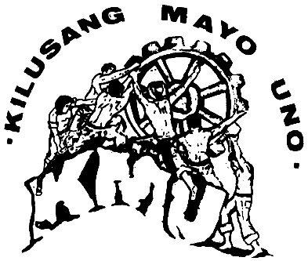
LEPANTO EMPLOYEES UNION
National Federation of Labor Unions
Kilusang Mayo Uno
Lepanto Mine Division
Lepanto, Mankayan, Benguet

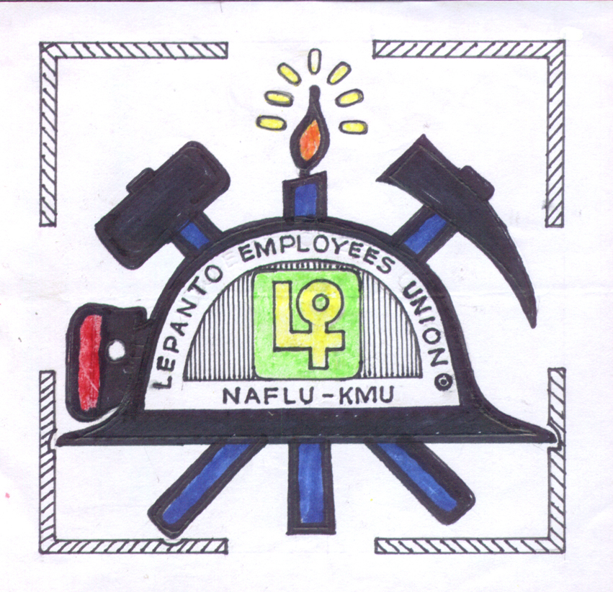

November 6, 2008
PRESS RELEASE
Contact Persons: Manuel B. Binhaon Jr.
President , LEU-NAFLU-KMU
Cp # 09074002387

Elma R. Awingan
NAFLU-KMU
Cp # 09086604934
PROTEST ACTION LED BY THE LEU-NAFLU-KMU TO OPPOSE THE LCMCo’s WORK ROTATION AND FORCE RETIREMENT SCHEME
Lepanto Mankayan Benguet- about 70 members and officers of the LEU-NAFLU-KMU, some worker's wives and the National Federation of Labor Unions-Kilusang Mayo Uno (NAFLU-KMU) assembled in front of the Company's General Office at 7:00 am-8:00am today to register protest to the company's management against the reduction of working days or the work rotation scheme.
The union had expect for a public dialogue with the management which was informed and scheduled to them earlier but unfortunately management failed to appear to the workers.
Though the management was not around, still the union staged a short program as Mr. Manuel Binhaon, the president of the union LEU-NAFLU-KMU read aloud the Resolution opposing the said scheme. He stressed that if the company will not listen to the workers demand, the union will push through with its campaigns in different forms. He added "the management will expect for a series of actions to be undertaken until they will address the problems/ issues concerning the workers".
The union also called the attention of the Local Government Unit of Mankayan to intervene and to make immediate actions on the said issue.
"It only shows that they (LCMCO) are not sincere and not willing to address the worker's demand to stop the implementation of the Work Reduction and Force implementation of Retirement" Binhaon added.
The said mobilization at the Management’s General Office is a result of the collective and majority decision of the union during its General Membership Assembly (GMA) last October 31, 2008 at the LEU-NAFLU-KMU Union Hall as a response to the management’s proposal to reduce the working days of the workers. The union viewed that this is a gross violation of their Collective Bargaining Agreement. The forced implementation of the vacation leave, rest leave, rest leave and sick leave as well as the implementation of force retirement is a manifestation of Unfair Labor Practices (ULP) and violation to the provision of the Labor Code
The LCMCO management issued a notice to the union dated October 27, 2008 about its plan to reduce the working days to 20 days per month with the implementation of the Rotation Work Scheme of all surface employees and some 119 underground employees to be effected on November 1, 2008. That same day the union immediately protested the proposal and asked the company not to implement the said scheme pending the consultation of the workers through a generalmembership assembly Instead of considering the Union’s request, the company again issued another memorandum dated October 31, 2008 stressing the immediate implementation of the Work Rotation Scheme that shall now affect all surface and underground and staff rank-and-file employees on November 1, 2008.
According to the management of the LCMCO Mine Division the reason for the reduction and cutting down of benefits is because of the low production/losing the company is experiencing.
The Company owes the workers to pay their unremitted social benefit contributions collected from them for some two years now. It should not be using these diversionary tactics to evade its financial obligations to the workers. The company is liable to estafa because of its non-remittance of Social Security System premiums and loan-payments amounting to P 52,220,509.43 and P 3.4 million un-remitted to PAG-IBIG since April 2007, non-payments of Back-wages starting November 2007 after the 24TH CBA was concluded on March 8, 2008. The company should stop delaying the release of wages as a tactic to persecute the workers.
The company’s leadership should be men enough and learn to respect and comply to a gentlemen’s agreement they had signed with the Union at government’s National Labor Relations Commission.
The NAFLU-KMU and the Cordillera Labor Center strongly condemn the company’s maneuvers for its drastic violation of workers’ right. This is a direct assault and attack against the workers’ rights to security of tenure, to fair wages and right to self-organization. This maneuver is clearly leading towards contractualization of labor, retrenchment and subsequently could lead to union busting.
The union is planning for another mass delegation on November 8, 2008 (Saturday) @ 10:00 in the morning at the Company's General Office.#

